Highwoods Community Primary School
“Learning for Life”

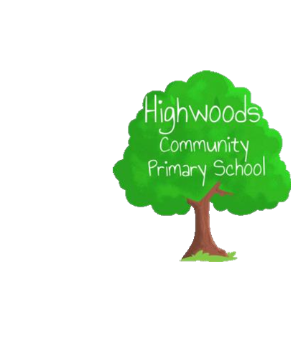
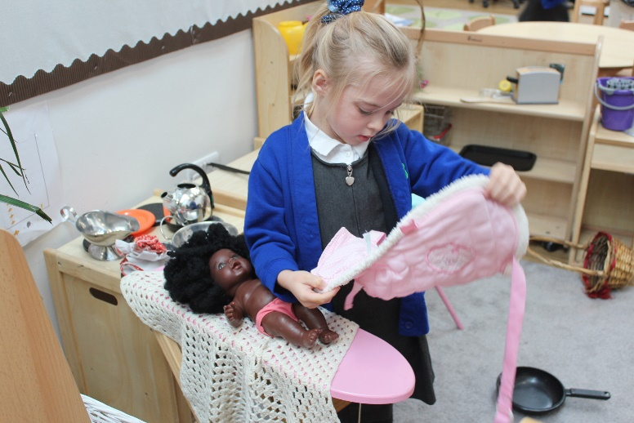
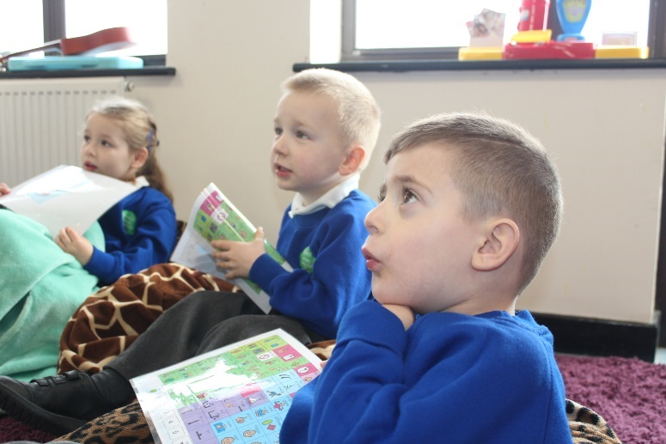
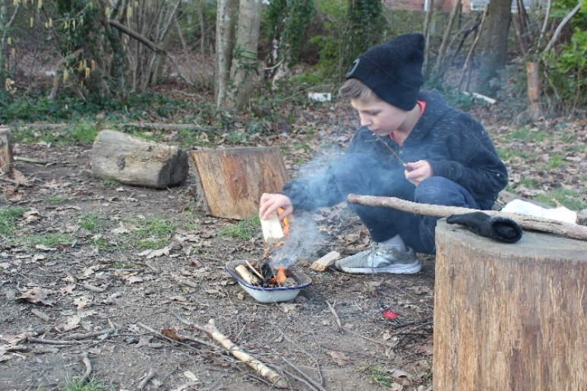
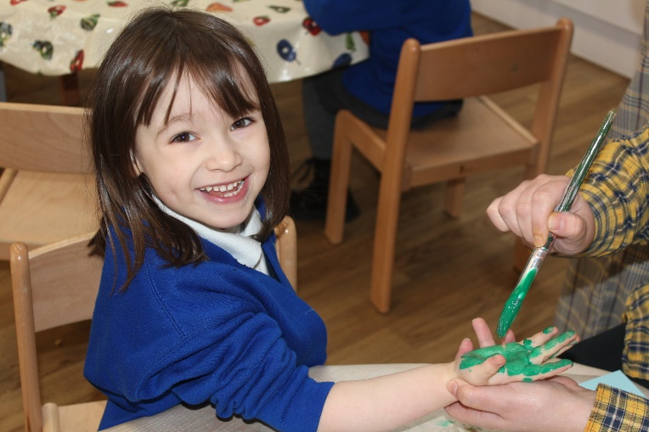

Prospectus 2023-2024

Welcome to Highwoods Community Primary School.
This school prospectus sets out the aims, policy and organisation of the school and it includes information about our school which you will need to know. We hope you will find our prospectus helpful and informative.

Highwoods is a Community Primary School for children aged 4 - 11 years.

The school is a modern building that opened in January 1989 and now has 14 class bases, 2 halls, 2 libraries and Forest Schools areas. There are also three group rooms and a resource area. There is a kitchen and provision is made for cooking school meals on the premises.
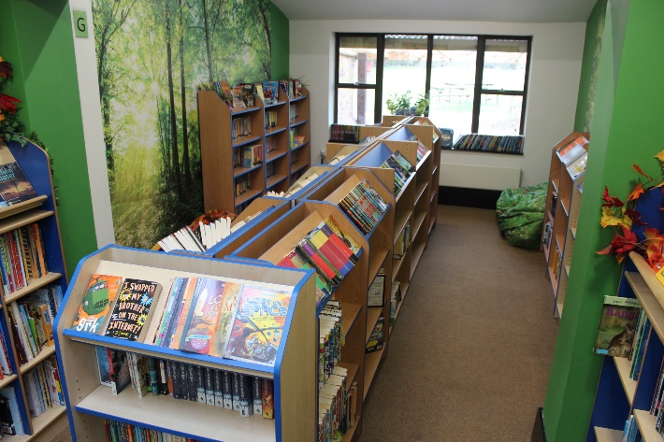
A large playground and playing fields are situated at the rear of the school. The grounds also include a valuable environmental area with a pond. The school has a log cabin for the use of Forest Schools and other dens used for various play activities throughout the year. There is an adventure playground with a safe surface. The school benefits from a seating area and specially designed sail shades to provide protection from the sun. The school building is surrounded by attractive paved areas and flower beds.
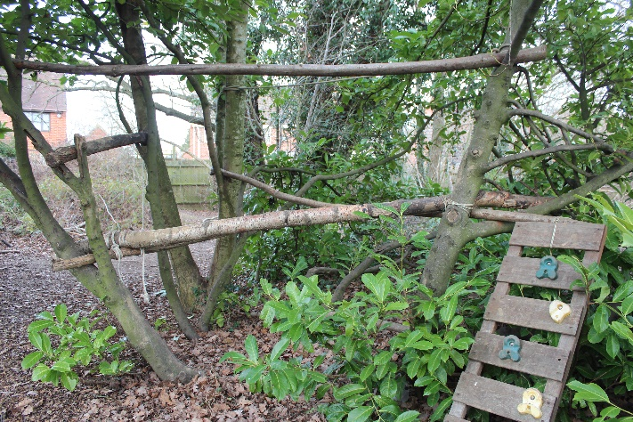
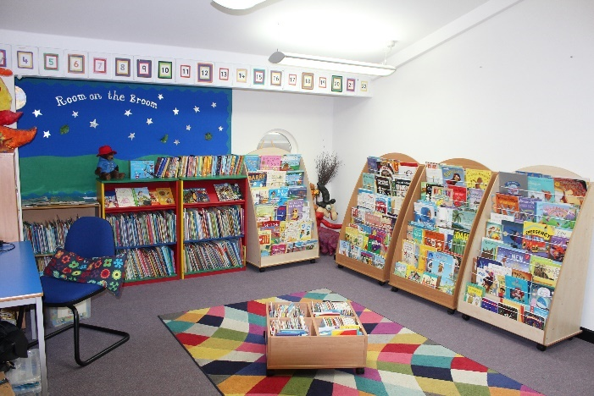
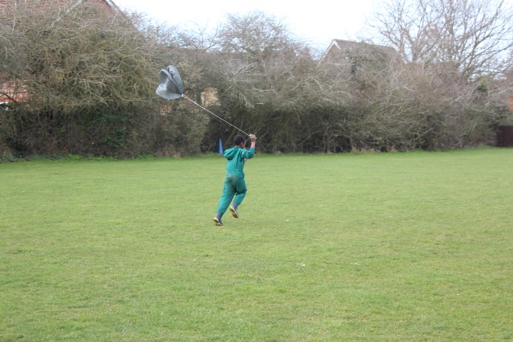

Highwoods Safeguarding Statement

Highwoods Community Primary School is committed to supporting young people and their families who may be suffering from significant harm with the aim of making sure they are kept safe both at school and at home.
“Leaders ensure that policies are up to date and meet the latest guidance. All staff are provided with safeguarding training and this is updated annually. All of the appropriate pre-employment checks are carried out on staff and volunteers. Staff know their pupils well. Any concerns are reported and considered carefully and prompt action is taken.”
“Pupils spoke confidently about the ways in which school leaders and staff work hard to keep them safe and look after them. Pupils say that they feel safe in school and staff agree. They know who to go to if they have a concern and feel supported by the ways in which issues are resolved.”
“Pupils know how to keep safe on the internet and the reasons for doing so. They understand what bullying is and explained that, while it may happen, albeit rarely, it is resolved quickly and effectively by staff.”
Ofsted 2019

Equality Statement

At Highwoods Community Primary School, we will abide by the law in respect of any legislation on equal opportunities including the Equality Act 2010.

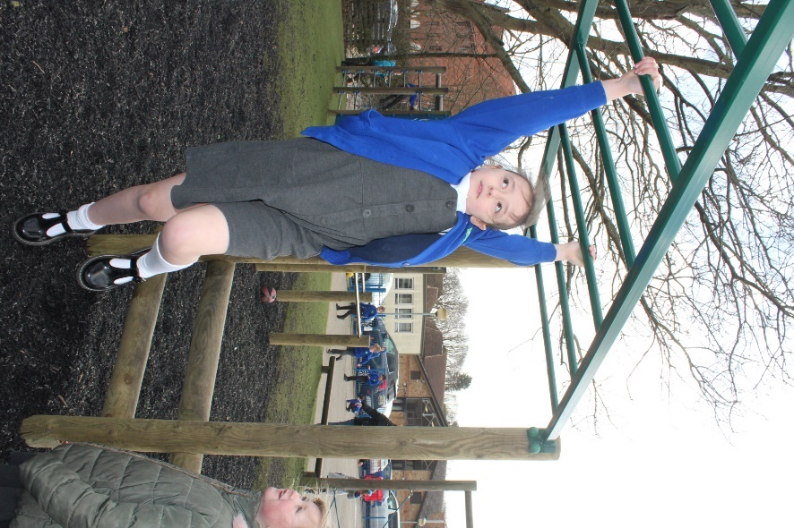

Vision and Aims

“Learning for Life”
At Highwoods, we are passionate about developing the whole child when supporting and nurturing young minds. Through our rich, varied curriculum, our
Forest Schools Programme and our love of learning, we provide a stimulating, safe and fun environment where children learn about themselves and the world around them. Throughout their time at Highwoods, children become equipped with the knowledge and key skills needed to succeed and take their learning further in the future in an ever-evolving society.

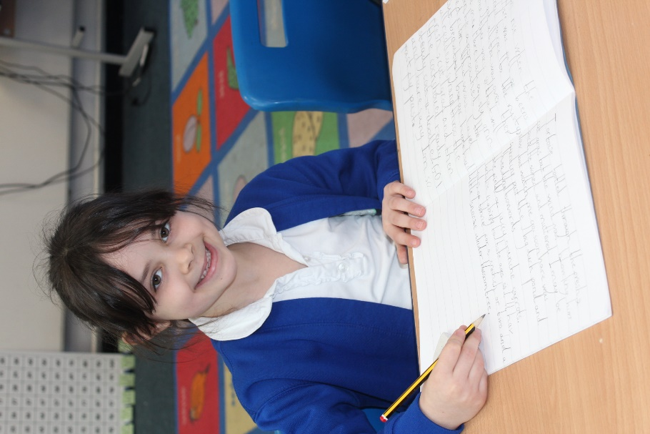

Curriculum Organisation

Highwoods Community Primary School follows the National Curriculum which was published in 2014. Our curriculum comprises the core subjects (Maths, English and
Science) as well as foundation subjects (Geography, History, Art, Design Technology, Computing, Religious Education, Personal, Social and Health Education, Music, Physical Education and French).

The Core Subjects:

English
English is taught daily. English learning comprises of daily reading sessions
(phonics in Key Stage One leading onto Whole Class Reading sessions in Year 2 and Key Stage Two), daily spelling lessons and daily writing lessons, which often include grammar, drama and speaking and listening. In Reception classes and Year 1 we follow the “Read, Write Inc” programme for teaching phonics and reading skills. Once children progress from this programme, we use the Oxford Reading Tree book scheme and have well-stocked libraries from which children can choose their books to read at home and at school. Skills acquired in reading, writing, grammar and spelling lessons are applied throughout the day in all subject areas.

Maths
Maths lessons take place daily as well as a daily “Maths Meeting,” where key arithmetic and mental maths skills are practised. The teaching of mathematics is based on the National Curriculum 2014, which places a strong emphasis on mental fluency, reasoning and problem solving. The school also places a strong emphasis on children developing quick mental recall of important number facts in order to form a firm foundation for written computation. Investigational work forms an important part of the mathematics curriculum and will enable children to acquire the necessary skills and concepts and to develop their mathematical thinking. Children will be involved in practising these skills and where appropriate will apply them to other areas of the curriculum. Much of the mathematics taught is of a practical nature, which helps the children's understanding of new ideas.
Computation is often linked with measurement, shape and money. The children learn to apply these skills to solve real life problems. An emphasis is placed on learning number bonds and children are expected to learn their multiplication tables.

Science

Science is a practical subject and from the earliest age children are encouraged to ask questions about the world around them and to look for answers to their questions. The science curriculum is studied in units which are revisited as a child progresses through the school. During the Foundation Stage, a wealth of first-hand experiences are provided for children to explore and make sense of the world around them. At Key Stage 1, the Science units are taught through discrete units and the work is integrated with thematic work where possible. At Key Stage 2, Science is taught as a discrete subject. At all ages there is an emphasis on practical investigations. The children are encouraged to think scientifically, to ask questions, and to plan and carry out investigations in order to answer their questions. A practical approach is adopted wherever possible.

The Foundation Subjects

Geography, History, Art and Design Technology (including Food Technology) are taught through our thematic curriculum. Physical Education, PSHE (Personal, Social and Health Education), Religious Education, Music, French and Computing are taught as stand-alone subjects or as part of our thematic curriculum depending on the subject of the theme.

Art
Art work arises from all areas of the curriculum and often affords opportunity for self-expression coupled with awareness of colour, pattern, space and shape. The school is enhanced by the displays of children’s artwork throughout the building.

Design Technology

Work in Design Technology is often linked to other aspects of the curriculum, particularly to Mathematics and Science. Children have the opportunity to design and make a variety of products. Food technology is incorporated into Design Technology.

Geography and History

History is taught through units which focus on a particular period in time. Children are encouraged to develop investigational skills and use different sources for their evidence. Visits to local places will be used to enhance their understanding. In Geography younger pupils will compare aspects of our immediate locality with surrounding areas. Older pupils learn about the wider world, including climate change and environmental concerns.

Computing

The school has many computer systems which are used to enhance work across the curriculum. We have a suite of laptops and iPads with a wide range of software and other technological resources. Interactive whiteboards are used in all the classrooms and the school hall. The mobile laptop and iPad suites provide the opportunity to teach the skills which the children will use across the curriculum. We have a robust policy on e-Safety and children are taught in an age-appropriate manner about responsible use of the internet, to be mindful of words and images they post on the internet and to treat their passwords as personal.

Modern Foreign Languages

As part of our curriculum at Highwoods, all children in Key Stage 2 learn French. They learn French through exploration of key phrases and other activities, eg the register and games in PE. Our specialist French teacher follows plans which are based on the KS2 framework for languages which enables progression from year to year.

Music

Children have opportunities to sing, play, compose and appraise music in weekly class music lessons. All pupils have the opportunity to play both percussion instruments and glockenspiels in these lessons. Children also participate in weekly singing assemblies where they have the opportunity to sing in a larger group. Key Stage 2 children are able to join the school choir which runs as an after school club. Paid music lessons are available for pupils to learn to play an instrument. Lessons currently available are for drumming, keyboard and guitar.

Physical Activity and Sports Premium

We encourage children to adopt a fit and healthy lifestyle. The physical activity curriculum includes individual and team activities, taught at a level appropriate to the needs and capabilities of the pupils. We are well resourced for the teaching of games and both halls are fully equipped for the teaching of dance and gymnastics. Swimming is also part of the Key Stage 2 curriculum. Professional coaching staff frequently teach at the school and we encourage pupils to participate in a wide variety of sports. Extra-curricular sport activities are offered to all pupils in the form of after school clubs. Each summer the children participate in our annual sports day and throughout the year children are involved in inter-house sport competitions.

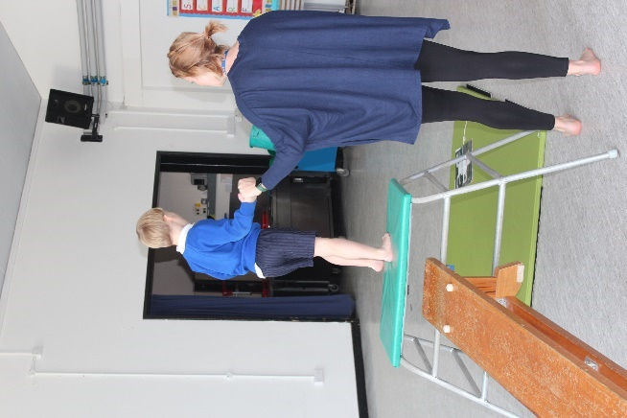

Religious Education

School assemblies and Religious Education are based broadly on Christian principles and set out to emphasise the belief that children should live and grow together in harmony. They also promote a greater understanding of other people’s needs both locally and worldwide. The RE syllabus covers a number of religions, including Christianity. Parents who wish their children to be withdrawn from Religious Education and assembly should consult the Headteacher and alternative arrangements will be made.

Relationships and Sex Education (RSE) and Health Education.
RSE forms part of our Personal, Social and Health Education curriculum. Learning about growth and development, family life, personal care, relationships and finally puberty and reproduction provides opportunities to ask questions and to learn about values and attitudes. Parents will be offered the opportunity to view video clips and other multi-media when teaching about puberty and reproduction.

Forest Schools
The ethos of Forest Schools is to offer children opportunities to achieve and develop in confidence, self-esteem and become independent. Forest Schools provides a safe but not always risk-free environment in which children can recognise and manage risks and use their own initiative. Adults are there to guide, encourage and praise.
Children in Years 3, 4, 5 and 6 walk to Highwoods Country Park. Children in EYFS, Year 1 and Year 2 participate in Forest Schools events on the school site.

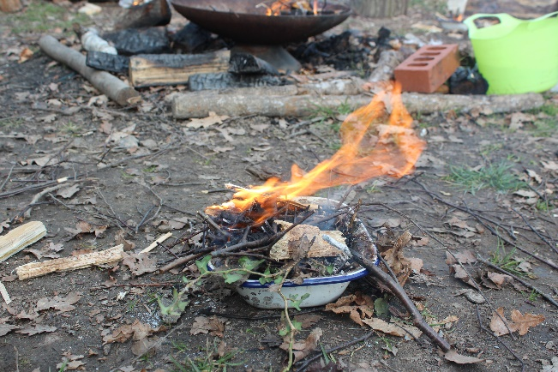
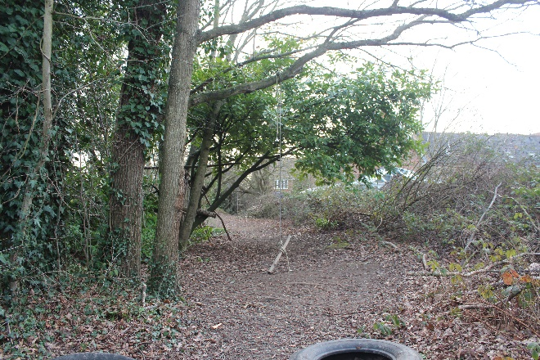
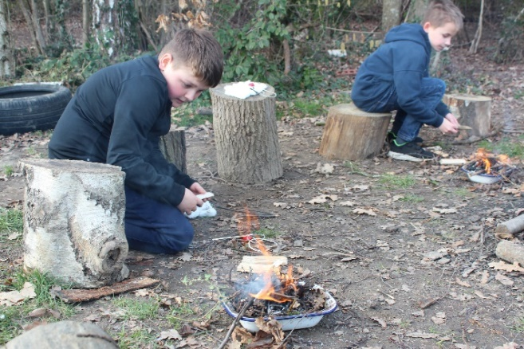
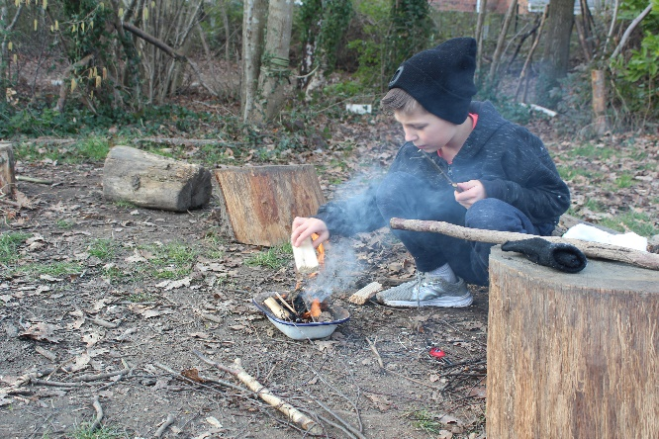

School Organisation
Children are organised into classes according to their birth year. At Highwoods we have two classes per year group, each with approximately thirty children. Children start at school in the September after their fourth birthday and begin, after a slightly staggered start, as full-time pupils. Children stay with their teacher for the year and move to the next year up the following September.

Early Years Foundation Stage (EYFS)
In the EYFS, children study a very broad curriculum which aims to develop skills which give a good foundation for learning at Key Stage One. At Highwoods, we aim to create a calm, happy atmosphere, placing great value on strong links between home and school. There is great emphasis placed on personal and social development so many activities are planned to encourage sharing and cooperation. Early reading, writing and maths skills are developed through daily whole-class sessions followed by independent and group activities which give children a chance to apply these new skills. Throughout and at the end of the Foundation Stage, EYFS teachers complete assessments on how children are progressing towards the Early Learning Goals. These assessments are shared with parents at Parents Evenings and in an end of year report.

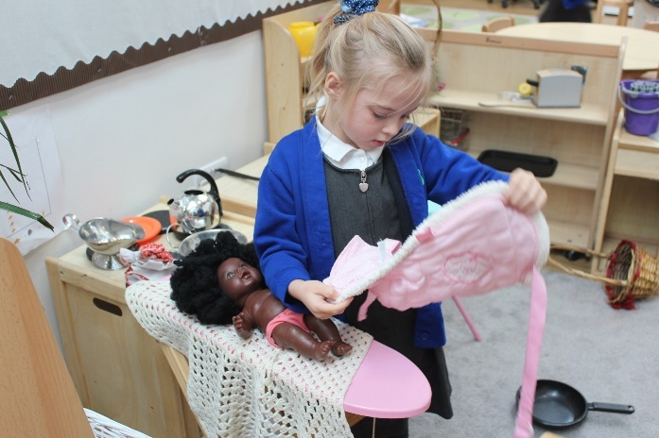
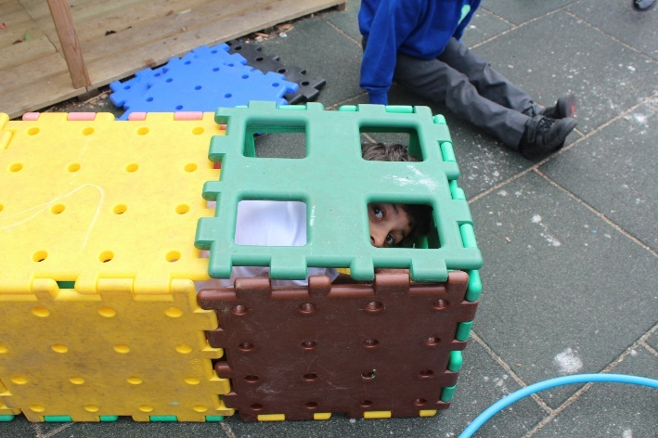
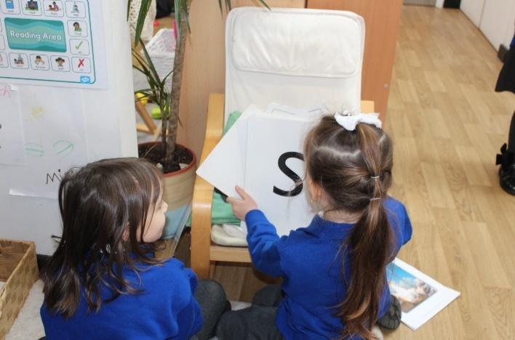
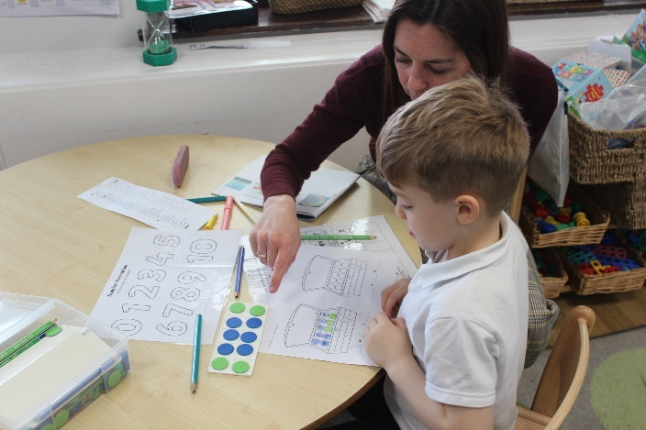

Learning Support
Children with additional educational needs are assessed on a regular basis by our Special Educational Needs Co-ordinator (SENCO). A new code of practice for SEND children was introduced in 2015. More details can be found on our school website and the DfE website. For children with individual plans (IPs) and Educational Health Care Plans (EHCPs), a specialist teacher may support them in class and for additional tuition.

Parental Involvement
We encourage parents to take an active interest in the education of their child and to feel involved in the work and life of the school. The school welcomes the involvement of parents in sharing their expertise with the children. We also welcome parents in as helpers both in the classroom and on educational visits. Parents who wish to help at the school on a regular basis must go through the necessary police checks, paid for by the school, before they start.

There are opportunities for parents to discuss their child’s progress at Parents Evening and to find out about various aspects of the curriculum. Parents are welcome to make appointments to discuss any aspects of school policy with the Headteacher. Each Autumn term we hold open mornings when prospective parents join us to see the school in action.

Parents are invited into school for music concerts, sports events, nativities, curriculum information events and thematic curriculum events.

School Council
Our school has an established School Council which is a body of pupils whose purpose is to represent their class and be a forum for active and constructive pupil input into the daily life of the school community. This is to encourage the development of citizenship throughout the school. The councillors meet regularly with a teacher and discuss items from feedback from their fellow pupils. School Council members, events and issues are displayed in the school corridor.

Eco-Committee
Our school has an established Eco-Committee. The elected eco-committee members meet regularly to discuss all aspects of environmental concerns. Action plans are then drawn up to implement any changes/improvements e.g. recycling, energy saving, reducing waste etc.

General Information
The following information has been set out in alphabetical order for ease of reference.

Absence from School
We take child safety and regular school attendance very seriously. In order to be sure that your child has either arrived at school or has been kept at home for a valid reason, we need to hear from you on the first day that your child is absent. You may contact us by phoning the school office on 01206 845887 to report a pupil’s absence, by using the school website “Report an Absence” page or email us at absence@highwoodprimary.essex.sch.uk. If we have not heard from you by 9.30 am, by following national and local authority policy we are obliged to make contact with parents to establish why a child is not at school.

You are strongly urged to avoid booking a family holiday during term time. Parents do not have a right or entitlement to take their child out of school for such a holiday, but schools may choose to grant leave of absence for exceptional circumstances only. In deciding whether or not to agree leave for a family holiday, schools will normally consider each case individually and will look at the child’s overall record of attendance. In most situations we will not agree leave during term time. If permission is not granted and you still take your child out of school for a holiday, the Local Authority may issue a penalty notice. This is a fine of £60 for each parent of each child.

Admission Arrangements
See Admissions Policy on our school website www.highwoodsprimary.com

Allergies
It is vital that you inform the school of any allergies from which your child suffers. Epipens must be kept in school for those who need them. We will require parents to complete a School Arrangement Protocol form and submit a recent photograph of the child. The school kitchen will advise parents about our lunch menus and every effort is made to ensure pupils with allergies do not eat inappropriate foods. The schools medical policy, which outlines our practice regarding allergies, is available on our website. Children wear a coloured wrist band if they have an allergy to make it clear to kitchen and lunchtime supervisor staff.

Animals on School Site

Animals of any kind are not permitted on the school site at any time.

Arrangements for Parents to Visit the School

Arrangements can be made to visit the school by appointment with the Headteacher, who will be pleased to see parents, show them the school and provide further information. If you would like to speak to the class teacher, they will be available after school to arrange an appointment.

Attendance

The school has targets to improve attendance and your child has an important part to play in meeting these targets. The attendance target for this school is 97%. Our aim is to achieve better than this however because we know that good attendance is the key to successful learning.
Our school attendance policy can be found on our school website.
If your child is regularly late or if their attendance fall below our expected standards you will be notified by the school and if the problem continues, you will be asked to attend a meeting with the Headteacher.
School Hours

Year Group | Morning Session | Lunch | Afternoon Session
EYFS | 8:45am-11:40am | 11:40am-12:40pm | 12:40pm-3:00pm
1 and 2 | 8:45am-11:45am | 11:45am-12:45pm | 12:45pm-3:00pm
3 and 4 | 8:40am-12:10pm | 12:10pm-1:10pm | 1:10pm-3:05pm
5 and 6 | 8:40am-12:40pm | 12:40pm-1:40pm | 1:40pm-3:05pm

Children should not arrive at school unaccompanied before 8:40am as the school cannot take responsibility for any child before this time, however, please ensure that your child is punctual as lateness is disruptive. Any child arriving after the completion of the register will be marked late.
During a normal school week, 23 hours will be spent on teaching at Key Stage 1 and 24 hours at Key Stage 2. These hours do not include registration, assembly and break times. Parents should collect their children promptly at the end of the day.

Behaviour, Conduct and Exclusion
It is the responsibility of all staff and parents to provide positive role models of good behaviour and conduct to our pupils. Throughout the school, children are praised for good behaviour, polite manners and high standards of work. The Highwoods High Five is displayed throughout the school to highlight the positive behaviour expected from all of our children. All children are expected to follow the Highwoods High Five which all adults in the school actively promote. If a child’s behaviour is of concern, a consultation is arranged between the teacher and parents so that a combined effort can be made to improve the situation and the advice of external agencies may be sought. In exceptional cases, the Headteacher may exclude a child from the school for a fixed period, or may propose permanent exclusion. Parents have a right to make representation (written in the case of fixed-term exclusion) to the Governing Body and Local Education Authority at the meetings called to consider the exclusion. Please see our Behaviour Policy on our school website for more information.

Bullying
The school has a written policy on bullying (Anti-Bullying Policy – available to view on the school website). Because we regard bullying as extremely serious, any incident is dealt with promptly. Please let us know immediately if your child experiences any problem of this sort. The school holds an annual anti-bullying week which also focuses on cyber-bullying.

Charging and Remissions Policy
The Charging and Remissions Policy is available on the school website. A paper copy is also available on request from the school office.

Complaints Procedure
Our Complaints Policy can be found on our school website. (See Appendix 1 for details)

Educational Visits

Educational visits are an important element in supporting children’s learning and ‘bringing the learning alive’. When these visits take place during school time, we ask parents to make a voluntary contribution towards the cost. The majority of trips are dependent on voluntary parental contributions. If any family finds these payments difficult, please contact the Headteacher to discuss this in confidence. No charge is made for parent helpers on these visits. See also our Charging and Remissions Policy on the school website.

Eleven-Plus Policy
The policy of Highwoods Community Primary School is to support children being entered for the selection procedure in the following ways:
Work planned for all children includes varying levels of challenge to ensure the needs of all children are met.
The Consortium of Selective Schools can provide parents with information on the Eleven-Plus tests. The year 6 teachers will discuss any queries on an individual basis and parents will be given further advice about their child. Practice papers can be purchased through most book stores and on the internet.

Emergency Closure
If the weather is very bad, heavy snow, for example, or there are local power cuts, it may not be possible to open the school. In these circumstances parents will be notified via SchoolPing, the school’s communication app. Children that are sent to school without adult supervision should be told that they must always report to the office even if they learn that the school will be closed. This is important to prevent children returning to an empty house. As the school will contact parents via School Ping, please make sure that you notify the school office immediately of any changes to your phone number or email address.

Equality

At Highwoods School, we abide by the law in respect of the Equality Act 2010. Our aim is to ensure that individuals or groups of individuals with protected characteristics (Race, Gender, Religion or belief or those without a religion or belief, Sexual orientation, Ethnicity, Impairment / disability, social economic status) are not disadvantaged or discriminated against and we will take prompt and positive action to address issues that arise. There are plans and policies in place to facilitate equality of access to the school building and the curriculum. Where appropriate, ‘reasonable adjustments’ will be made to enable equality of access and participation for disabled pupils. For details, please see our Inclusion and Equality Policy, Behaviour Policy, Anti-bullying Policy and SEND Policy (all of which are available on our school website).

Extra-Curricular Activities
Clubs take place before school, during the lunch hour or after school. Their exact nature varies with the time of year. The activities may include Art, Choir, Netball, Football, Lego and Athletics. Please see our school website for our current range of extra-curricular clubs.

First Aid

Minor injuries, such as cuts and grazes, are dealt with by staff trained in First Aid. If your child is unwell or has a more serious injury, we will contact you as soon as possible. A record is kept of all incidents that require medical attention, with the exception of small cuts and grazes, and a slip is sent home with your child to inform you. Please make sure we have an emergency telephone number in addition to your home number if you are not at home during the day.

Governing Body
The school has a Governing Body which is responsible for governance, strategy, policy, and the Headteacher is accountable to the Governing Body. Parent Governors have an important role and are elected by parents of pupils at the school. They have every opportunity to play their full part in decision making and it is our policy that whenever practicable a Governor is involved with teaching staff appointments, including being part of the interviewing panel. The Governing Body of the school consists of the Headteacher, parents, representatives from the local community and the Local Authority. A full list of current Governors can be found on our school website.

Holidays

See Appendix 1 for the school term dates and holidays and “Absence from School.”

Induction of new Foundation Stage children
Parents of pre-school children are welcome to make an appointment to visit the school at any time. The common application form enables parents to apply for up to four schools in preference order.

After primary school places have been allocated, usually after Easter, parents of new entrants are invited to an evening Induction meeting to learn about how the Foundation Stage is organised. Parents and children are also invited to join their new reception class for a ‘Stay and Play’ session during the summer term so that the children become familiar with the new environment. The children will also be invited to spend short sessions in their new classroom with their new teacher in order to become familiar with their classroom environment and adults that will support them. Finally, we hold Parent Consultations before children start school which are a chance for parents to talk to the class teachers about their child.

Jewellery
Children should not wear jewellery except watches and stud earrings. On days when they are involved in PE or Games, we strongly recommend that no jewellery at all is worn as any damage resulting from the wearing of these items cannot be regarded as the responsibility of the school or the Education Authority. Children with pierced ears will not participate in PE sessions unless they can be removed.

Fun4Kids
There is an independent childcare provision, which is run by Fun4Kids, situated on the school site and this can provide before and after school care for pupils between 7am and 8.40am (breakfast club) and 3pm – 6.30pm. The club is also available for the majority of the school holidays. The phone number is 07944 698731 or email : fun4kidshighwoods@gmail.com or you can click the link on our website.

GDPR – Data Protection
The school is compliant with Data Protection law. Please refer to the website for information in this respect.

Lost Property
Lost property is kept in the family room in the school entrance foyer and parents are welcome to check to see if their child’s property has been handed in. Labelled garments are always returned to the child but each year many items which have not been named remain unclaimed. Items which remain unclaimed at the end of each term will be disposed of in our PTA clothes recycle bin or shared in our school uniform give away held regularly.

Medicines
If your child has been ill but is regarded by the doctor as fit to return to school, it may then be necessary for you to complete a permission slip for a member of staff to administer prescribed medication. Prescribed medicines can only be administered for doses of 4 times a day or more. Medicines must be labelled with the child’s name and class and must be provided in the original packaging. Non prescribed medicines may be administered by school staff. We try to ensure medication is given at the correct time, parents should be aware that this is not always possible. If parents prefer, then they can make arrangements to come in and give the medication themselves if the timing of the dose is important. All medicines should be collected at the end of the day, or for unprescribed medication, at the end of each school year. Pupils suffering with asthma should keep an inhaler in school. These are always kept where children have easy access to them. The school nurse team regularly advises us on updating policies for medicines in schools.

Meeting children from School (see also – Road Safety)
You are welcome to wait for your child in the paved area outside the school. Pre-school children should be closely supervised. It is important that children are collected on time from the classroom door. If you are delayed collecting your child, please let the school office know as soon as possible. Families should be off the school site by 3.10pm so that extracurricular clubs can begin.

Non-Pupil Days/Inset Days
The school allocates 5 days a school year as Non-Pupil Days. These days are communicated to the parents in advance via the website, newsletter and PING.
The children do not attend school on these days as they are dedicated to staff training. The dates vary from year to year.

Parents’ Letters
Parents are kept in touch with forthcoming events through the means of half-termly school newsletters. School newsletters are posted on the school Website and sent out to parents via School Ping. Paper copies are available at the school office.

Parents Teacher Associated (PTA)
We have an active and hardworking PTA committee which organises fund-raising and social events. It depends on parents giving of their time and effort to maintain its success and we hope that by contributing you will feel really involved in the life of school. Events include; quiz nights, fashion shows, discos, clothes recycling and a Summer Fair. Contact the PTA at pta@highwoodsprimary.com. You can also visit their Facebook page.

PING
School Ping is our communications app. We use this app to send letters, messages, notifications, forms and all general communication with our parents. It is vital that you download this app as a way for us to communicate with you. Please ensure if you change your email address or your phone number that you advise the school immediately to prevent missing vital information.
Information how to download and use the app will be given to you when your child starts school.

Play Activity Leaders (PALS)
The Playground Leaders are taught a variety of games and encourage group play. The PALS are led by a Play Activity Leader who organises a timetable for the children helping her. Children who are PALS wear distinctive caps and bibs and are there to play with children and lead games.

Prefects

Year 6 prefects are chosen because of their high standards in all areas – work, attitude, presentation, relationships and responsibility. They are given many duties throughout the school which contribute to the welfare of pupils; for example, they assist younger children in the dinner hall and they show visitors around the school for special events.

Road Safety

Our pupils are regularly taught about road safety. To ensure that it is as safe as possible for children leaving the school premises at the end of the day, parents should not park near the school. Whenever possible, children should be brought to and collected from school on foot. Walking to school is beneficial for children’s health and fitness and assists in the development of road safety skills. The police have requested that we remind parents that parking is a problem in the area so when it is essential that you use your car, please do so with care, avoiding yellow lines and blocking roads and turnings.
Children in Year 6 participate in a Level 2 Bikeability course.

Safeguarding and Child Protection

The school has an important role to play in ensuring the safety of all its pupils. Teachers are in a good position to observe changes in behaviour or signs of non-accidental injuries. Where there are concerns, the school has a duty to refer cases to the Social Care Department. All the staff have undergone safeguarding training and are aware of child protection issues in school and during visits.

School Gateway
School Gateway is a cashless payment app the school uses for all payments to the school. These can include school lunches, trips, clubs and snack money etc
When your child starts school you will receive information on how to download and use the app.

School Meals
It is our priority to offer a school meals service which provides pupils with a healthy balanced diet based around sourcing local fresh ingredients and creating high quality meals cooked by our own staff on site. We continue to develop our food and service to meet and exceed the government requirements for school meals. The school meal menus can be found on our website. They run on a three week cycle and are changed termly.
All children in key stage one (Foundation, Year 1 and Year 2) are entitled to a free of charge school lunch under the Universal Infant Free School Meal scheme.
From Year 3 – Year 6 children can order lunches at a cost of £2 per day payable through our cashless app School Gateway.
If your child qualifies for free school meals due to the family income being lower than the threshold amount, your child can receive a free school meal for all of the primary school years. For more information please see Apply for free school meals - GOV.UK (www.gov.uk)
Parents can opt for their child to have a packed lunch. We encourage all parents who supply a packed lunch to follow healthy eating guidelines. Home supplied lunches may include a non-fizzy drink in a non-breakable bottle or flask. Children should not bring glass bottles, fizzy drinks or sweets. Our Highwoods packed lunch guidance can be viewed on our website.

School Uniform
Children wear the uniform detailed in Appendix 6. Examples of this can also be seen on our website. We ask that all children wear shoes rather than trainers to school. Please make sure your child’s clothes are all named. Children will need to wear their PE kit on the days they have PE lessons. Information about this will be provided by the class teacher.

Secondary Education
We maintain close links with The Gilberd School and the majority of pupils transfer there in Year 7. During Year 6, children may take the Secondary Selection Procedure organised by selective schools (see Eleven-Plus Policy Section).
Applications for a secondary school place are communicated via Essex County Council and are awarded in line with the secondary school catchment and admission priorities.

Smoking and Vaping
Smoking and vaping of any kind is not permitted on any part of the school site.

Students
It is the policy of the school to provide placements for students. We sometimes have student teachers on teaching practice who work with a particular class. They work alongside staff in teaching the curriculum planned for the term and gradually take increased responsibility for the class. We also offer places to work experience students.

Sweets and Drinks
Children should not bring sweets to school for playtime but should bring a healthy snack in line with our school snack policy. Children need to bring a named water bottle which they can keep in class to drink from during the day. All children in Key Stage 1 receive a free piece of fruit or vegetable each day. Children in Key Stage 2 are encouraged to bring a healthy snack for playtime. There is a charge of £15 per year in Foundation Stage to pay for snacks provided by the school during the day.

Swimming
Swimming is taught as part of the National Curriculum and delivered during Key Stage 2. This requires a voluntary contribution from parents to meet the cost of tuition and transport. It is important to remember that a voluntary contribution is essential for this activity to take place. The school cannot fund this activity from our funds.

Trips and Visits
The school arranges many trips throughout the year groups including a residential year 6 trip, zoo, planetarium, London, seaside, Warner Bros, Harwich, Layer Marney Towers and Duxford to name but a few.
Visits to the school include a Stoneage experience, farm animal visits, History of Toys, Great Fire of London, World War II and many more. These visits enable the children to spend a full day emerged in their topic and invaluable hands-on experiences.
Charges cannot be made for education during school hours, but voluntary parental contributions will be sought to enable the school to provide a full range of educational activities. If parents are unable to contribute please contact the school office who will always treat your personal circumstances in complete confidence.

No child will be discriminated against on the basis of their parent’s circumstances or unwillingness to pay.

Website
The school website can be found at www.highwoodsprimary.com You can access information about the school and new pictures of events and activities. Information includes the school diary, lunch menus and all our policies and procedures. The website also provides a link to the most recent Ofsted report which provides a detailed picture of the school’s strengths and areas for development.

Appendix 1
Essex County Council School Term and Holiday Dates for Community and Voluntary Controlled Schools - Academic Year 2023-2024

September 2023 |  |  |  |  |  |  | October 2023 |  |  |  |  |  |  | November 2023 |  |  |  |  |  |  | December 2023
M | T | W | T | F | S | S | M | T | W | T | F | S | S | M | T | W | T | F | S | S | M | T | W | T | F | S | S
 |  |  |  | 1 | 2 | 3 |  |  |  |  |  |  | 1 |  |  | 1 | 2 | 3 | 4 | 5 |  |  |  |  | 1 | 2 | 3
4 | 5 | 6 | 7 | 8 | 9 | 10 | 2 | 3 | 4 | 5 | 6 | 7 | 8 | 6 | 7 | 8 | 9 | 10 | 11 | 12 | 4 | 5 | 6 | 7 | 8 | 9 | 10
11 | 12 | 13 | 14 | 15 | 16 | 17 | 9 | 10 | 11 | 12 | 13 | 14 | 15 | 13 | 14 | 15 | 16 | 17 | 18 | 19 | 11 | 12 | 13 | 14 | 15 | 16 | 17
18 | 19 | 20 | 21 | 22 | 23 | 24 | 16 | 17 | 18 | 19 | 20 | 21 | 22 | 20 | 21 | 22 | 23 | 24 | 25 | 26 | 18 | 19 | 20 | 21 | 22 | 23 | 24
25 | 26 | 27 | 28 | 29 | 30 |  | 23 | 24 | 25 | 26 | 27 | 28 | 29 | 27 | 28 | 29 | 30 |  |  |  | 25 | 26 | 27 | 28 | 29 | 30 | 31
 |  |  |  |  |  |  | 30 | 31
January 2024 |  |  |  |  |  |  | February 2024 |  |  |  |  |  |  | March 2024 |  |  |  |  |  |  | April 2024
M | T | W | T | F | S | S | M | T | W | T | F | S | S | M | T | W | T | F | S | S | M | T | W | T | F | S | S
1 | 2 | 3 | 4 | 5 | 6 | 7 |  |  |  | 1 | 2 | 3 | 4 |  |  |  |  | 1 | 2 | 3 | 1 | 2 | 3 | 4 | 5 | 6 | 7
8 | 9 | 10 | 11 | 12 | 13 | 14 | 5 | 6 | 7 | 8 | 9 | 10 | 11 | 4 | 5 | 6 | 7 | 8 | 9 | 10 | 8 | 9 | 10 | 11 | 12 | 13 | 14
15 | 16 | 17 | 18 | 19 | 20 | 21 | 12 | 13 | 14 | 15 | 16 | 17 | 18 | 11 | 12 | 13 | 14 | 15 | 16 | 17 | 15 | 16 | 17 | 18 | 19 | 20 | 21
22 | 23 | 24 | 25 | 26 | 27 | 28 | 19 | 20 | 21 | 22 | 23 | 24 | 25 | 18 | 19 | 20 | 21 | 22 | 23 | 24 | 22 | 23 | 24 | 25 | 26 | 27 | 28
29 | 30 | 31 |  |  |  |  | 26 | 27 | 28 | 29 |  |  |  | 25 | 26 | 27 | 28 | 29 | 30 | 31 | 29 | 30
May 2024 |  |  |  |  |  |  | June 2024 |  |  |  |  |  |  | July 2024 |  |  |  |  |  |  | August 2024
M | T | W | T | F | S | S | M | T | W | T | F | S | S | M | T | W | T | F | S | S | M | T | W | T | F | S | S
 |  | 1 | 2 | 3 | 4 | 5 |  |  |  |  |  | 1 | 2 | 1 | 2 | 3 | 4 | 5 | 6 | 7 |  |  |  | 1 | 2 | 3 | 4
6 | 7 | 8 | 9 | 10 | 11 | 12 | 3 | 4 | 5 | 6 | 7 | 8 | 9 | 8 | 9 | 10 | 11 | 12 | 13 | 14 | 5 | 6 | 7 | 8 | 9 | 10 | 11
13 | 14 | 15 | 16 | 17 | 18 | 19 | 10 | 11 | 12 | 13 | 14 | 15 | 16 | 15 | 16 | 17 | 18 | 19 | 20 | 21 | 12 | 13 | 14 | 15 | 16 | 17 | 18
20 | 21 | 22 | 23 | 24 | 25 | 26 | 17 | 18 | 19 | 20 | 21 | 22 | 23 | 22 | 23 | 24 | 25 | 26 | 27 | 28 | 19 | 20 | 21 | 22 | 23 | 24 | 25
27 | 28 | 29 | 30 | 31 |  |  | 24 | 25 | 26 | 27 | 28 | 29 | 30 | 29 | 30 | 31 |  |  |  |  | 26 | 27 | 28 | 29 | 30 | 31

 | = Schooldays |  | = School Holidays |  | = Bank Holidays

= Weekends X = Non Pupil Days

In addition, schools allocate five non-pupil days out of the school days indicated,
or the equivalent in disaggregated twilight sessions.
Autumn Term: | Monday 4 September 2023 – Wednesday 20 December 2023  Half Term 23 October – 27 October | 73 days
Spring Term: | Thursday 4 January 2024 – Thursday 28 March 2024  Half Term 19 February - 23 February | 56 days
Summer Term: | Monday 15 April 2024 – Tuesday 23 July 2024  Half Term 27 May – 31 May, and May Bank Holiday - 6 May | 66 days  _______  195 days

Published 25.04.2005 by Education Information Management
The Schools Service
Essex County Council, PO Box 47
Chelmsford CM2 6WN Tel. 01245 436242 / 436276

Appendix 2

Highwoods School Staff
Headteacher Paul Disley
Deputy Headteachers Sharon Corton Martha Mclewin
Senior Leadership Team
Kate Bradley Vicki Costanzo
SENCO Vicki Costanzo

Teaching Staff: | Learning Support Staff: | Office Staff: | Kitchen Staff:
Mrs Nicola Bedford  Miss Kate Bradley  Mrs Jennifer Buckingham  Miss Hayley Chapman  Miss Jessica Collins  Mrs Sharon Corton  Mrs Vicki Costanzo  Miss Sarah Halls  Mrs Hannah Harbord  Miss Kimberley Jones  Miss Martha McLewin  Mrs Emma Parker  Mrs Claudia Parsons  Madame Landry Reed  Miss Amelia Roberts  Mrs Katy Roberts  Mrs Amelia Shaw  Mrs Beth Tolhurst  Mrs Rachel Wilkins | Mrs Heidi Angira  Ms Gail Bennett  Mrs Veronica Bromley  Mrs Sam Cartwright  Mrs Diane Cavens  Mrs Gaynor Cordner  Mrs Denise Denmead  Miss Stacy Dixey  Mrs Alex Egerton  Mrs Debbie Emm  Mrs Tracey Fisk  Mrs Lauren Freeman  Miss Ellie Johns  Mrs Marieke Hooker  Mrs Kirsty Hunt  Miss Emmalene King  Mrs Leonora Michael  Mrs Hayley Mitchell  Ms Anne Munford  Mrs Natasha Rice  Mrs Julia Rickett  Mrs Annie Ross-Sercombe  Mrs Gail Williams  Miss Sasha Wiseman  Miss Ingrid White  Miss Yvette Witney  Miss Helen Woolnough | Mrs Helen Bailey  Mrs Julie Gooderham  Mrs Natalie Jamieson  Mrs Karen Todd  Mrs Sarah Taylor | Mrs Andrea Collins  Mrs Susan Murrell  Miss Tracey Nicholls  Mrs Leanne Kemble
 |  | Midday Staff: | Premises Staff:
 |  | Miss Sarah Bilton- Heenan  Mrs Denise Denmead  Mrs Stacey Dixey  Mrs Emma Endean  Mrs Tracey Fisk  Miss Emmalene King  Mrs Nadine Marjeram  Mrs Janet Marven  Mrs Leonora Michael  Miss Yvette Witney  Miss Ingrid White  Miss Natasha Elliott  Mrs Thenmozhi Kulandaisamy | Mr Andy Jamieson  Mr Adam Cordner  Mrs Gina Jarrett

Appendix 3

School Uniform
Royal blue polo shirt
Royal blue cardigan/jumper
Grey skirt or pinafore dress
Grey shorts or trousers
Blue and white gingham dress
Blue/white/grey socks/tights
Sweatshirts/reversible fleeces and cardigans in our own school design (these can be ordered from www.mapac.com)
Black shoes (no boots please, until inclement weather)
Trainers should only be worn for some PE activities
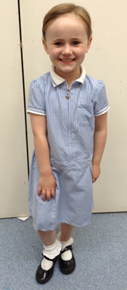
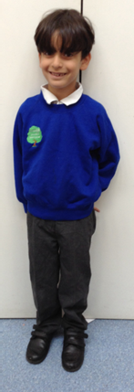
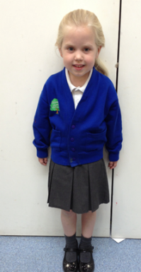
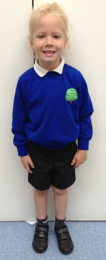

PE Kit
Blue shorts
Black or white plimsolls
Trainers and a blue tracksuit are recommended for outdoor lessons
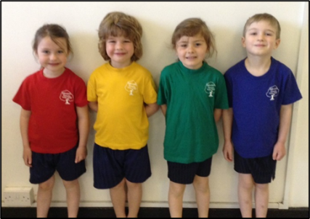
A large named drawstring bag (to hold PE Kit)
PE T-Shirt according to House Colour:
Chestnut – Red
Ash – Blue
Fir – Green
Oak – Yellow
PE tops are made by Fruits of the Loom and are on Amazon for around £2.
It is essential that all items of clothing, including footwear are named.
Appendix 4
School Data 2022

Our current school data is the first to be published since the COVID lockdowns.


